|  |  |
| --- | --- |
| **Name:- Aryan Dilipbhai Langhanoja** | **Roll Number:- 92200133030** |
| **Subject Name and Code:-** Foundation Skills On Sensor Interfacing (01CT1103) | **Date of Experiment:- 18-12-2022** |

|  |  |
| --- | --- |
| Task:- |  |

For loop

|  |  |
| --- | --- |
| Components: |  |

* Arduino Uno R3
* LED
* Jumper Wires (Male To Male)
* Bread Board
* Laptop Or PC

|  |  |
| --- | --- |
| About the Project:- |  |

* In thisproject, we are going to use Arduino to blink the LED with for loop. We will connect LEDs with Digital pins 2 to 7. And we will consider an array of that. Now, we will run a for loop. In the loop, we will call an element of array one by one, and according to that the respective LED Will blink.

|  |  |
| --- | --- |
| Output:- (you circuit implementation |  |

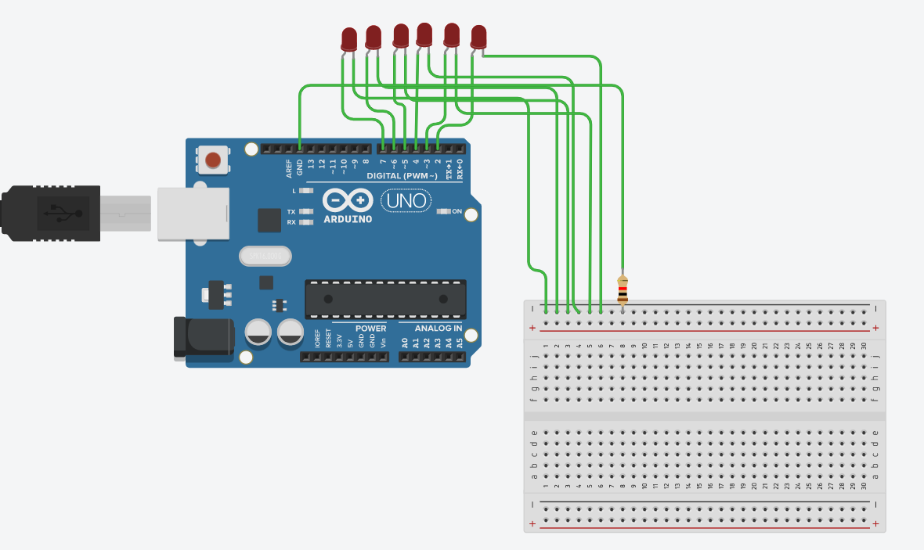

|  |  |  |
| --- | --- | --- |
| Schematic:- |  |  |

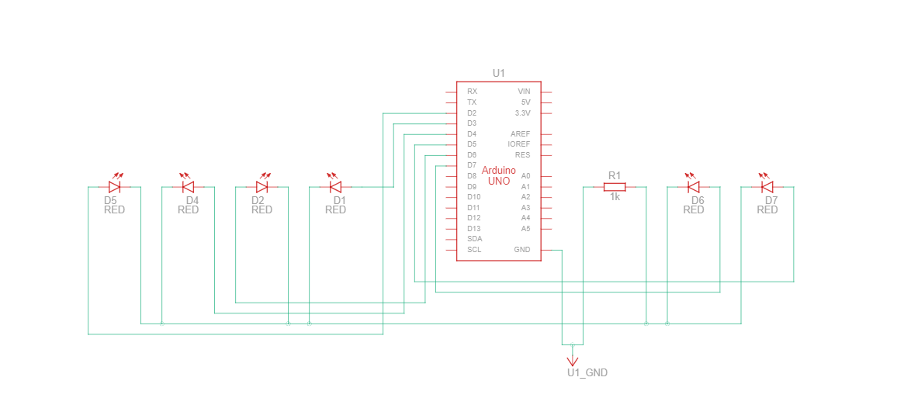

|  |  |
| --- | --- |
| Code:- |  |

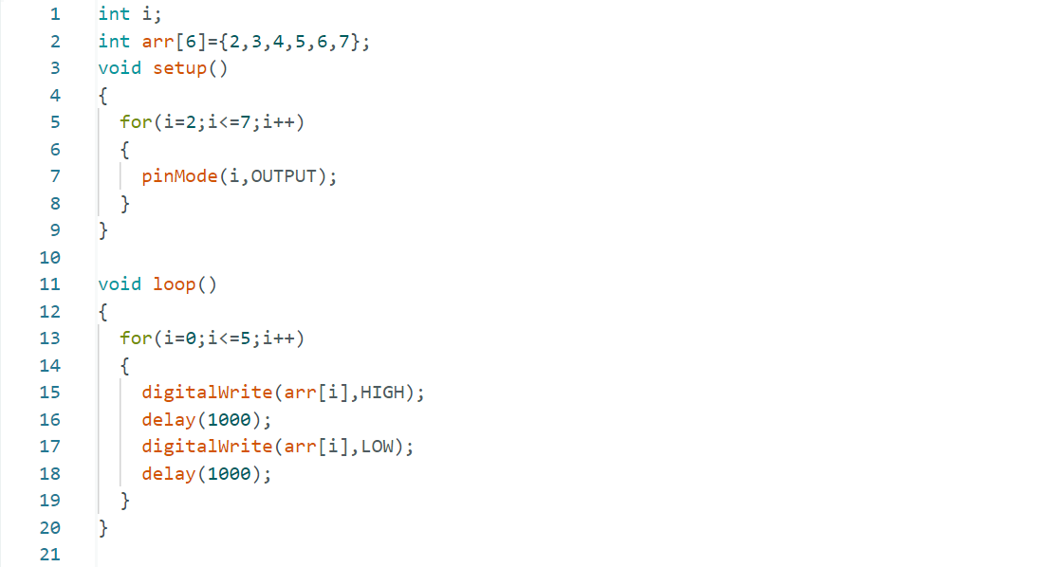

|  |  |
| --- | --- |
| Conclusion:- |  |

* In this project, we learnt how to use for loop.